**Cloud Computing**

**Cloud Computing**- cloud computing is a on demand availability of computer. System resource especially data storage and computing power without direct mange by user

It manes someone else computer server that are accessed. Over the internet and the software database run on this servers .

1. Types of cloud-
2. Public cloud :-The are environment typically .Created from organization not owned. by user

eg: Aws google. Cloud. IAM cloud

2)Privat cloud. This is for a social environment for a community purpose

3)Hybrid cloud-It is combining of a public and private cloud

4)Multi cloud -it is all clouds are available it is also community cloud.

Architecture of cloud computing

It’s a combination of both SOA {service oriented architecture } it is divided into two parts

1. Frontend 2)Backend

Advantages of cloud computing

1)Reduce cost

1. Give good user accessibility
2. Make it more modularized
3. Provide high security
4. Make over all cloud computing system simpler

**Cloud service modules**

1. **IASS** [ Infrastructure as service ]

It is also hardware as service (haas)

Eg. Micro soft ,azure ,rockspace

Characteristic of IASS

1. **PASS** [ Plat form as a service ]

It is created for the programmer to developer

Test run and manage the application

Characteristic of PASS

1. Provides on abilities to auto – scale
2. Support multiple language
3. Support from work
4. Integrates with web service and database

Eg . windows Azure

**3)SAAS**  [software as service]

- It is also known as “on demand software

-It is hosted by cloud service provider

-User can assess this application with help on internet connection and web browser

Characteristic

1. Hosted on remote server
2. Accessible over the internet
3. Managed from central location

Eg . google apps ,scalforce zendes

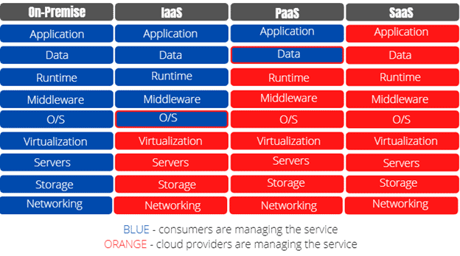

**AWS**

* AWS . amazon .com => domain of AWS
* According to scope their three type of services

1. Global => Its available or access any location
2. Rrgion=>Assess from particular
3. Availability => access depend om availability

Aws [amazon web service] is the words most comprehensive and broadly adopted cloud plat form offering 200 fully featured service from data center

Globally

* **Services :-**

1. **Iam :-**

It is global service

Free of cost

Iam roles anywhere

**What is iam :-** AWS Identity and Access Management (IAM) is a web service that helps you securely control access to AWS resources. With IAM, you can centrally manage permissions that control which AWS resources users can access. You use IAM to control who is authenticated (signed in) and authorized (has permissions) to use resources.

* **Resource -** 
  1. User
  2. Group
  3. Roles
  4. Policies

**Creation of user in iam**

1. Choose access type i.e console access or programtic access if you want programmatic access then check box .
2. Assine permeation to user
3. You can add permeation using three ways
4. Add user to group.
5. Copy permission
6. Attach police directliy.
7. check summary of your user then create user.
8. After creatin user in security credentilals you see access type and MFA and many options

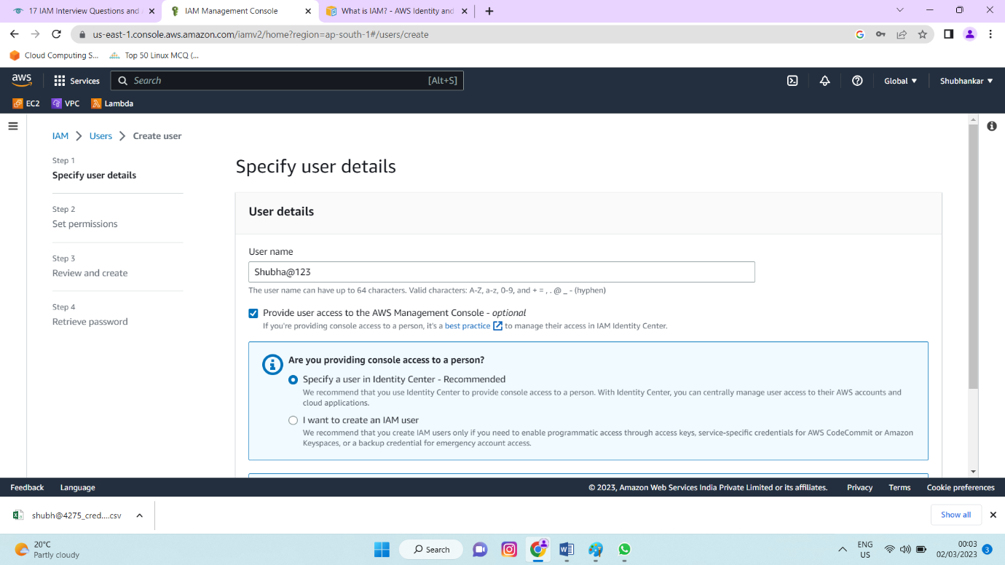

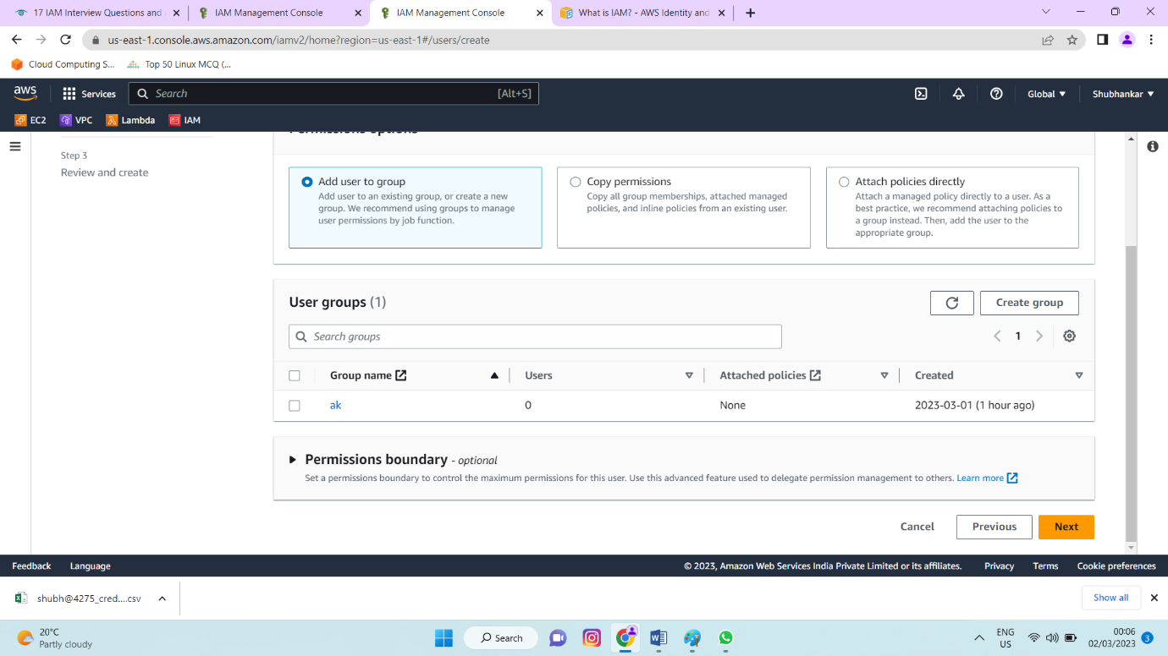

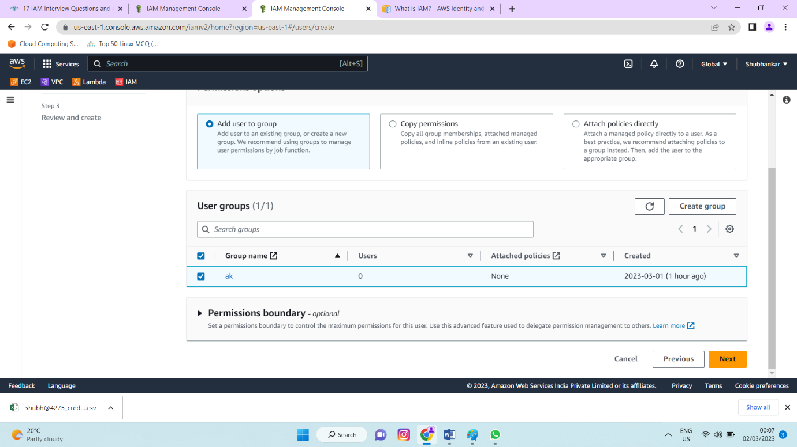

**Create user in aws management console :-**

1. Choose user from left panel
2. Select entity type (aws service)
3. Select use case ec2 or lamda
4. Select policies or you create your own policies.
5. Add your role name if you can give tags then add tags.

**1)Which are the key features of AWS IAM?**

Access control to AWS resources Multi-factor authentication (MFA) Federated access Analytics

**2)Explain AWS IAM Policies.**

IAM Policies are how you determine who has access to what resources in your account. For example, you could allow users access to all Amazon EC2 instances within your AWS account, or just a specified instance.

**3)What is the IAM Hierarchy of Privileges**?

IAM user

Root user

User with temporary credentials

**4)What are the features of AWS IAM**?

There are many features of AWS IAM few of them would be:

Identity federation

Secure Access to AWS resources for applications that run on Amazon EC2

Granular permissions

Multi-factor authentication (MFA)

Integrated with many AWS services

Free to use

**5)What is the importance of IAM**?

With an increase in security threats and user privacy preferences turning more difficult to handle, IAM has started to play a crucial role for organizations, irrespective of the industry and size. IAM is vital at a time when passwords get hacked within seconds, data breaches turn a frequent occurrence and intruders infiltrate government as well as organizational agencies.

**6)What are the key capabilities provided by AWS IAM?**

Access control to AWS resources

Multi-factor authentication (MFA)

Federated access Analytics

**7)Why do we need MFA?**

**Answer:**

Multi-factor authentication is an important security measure that adds an extra layer of protection to your account. By requiring more than one form of authentication, it makes it more difficult for someone to gain unauthorized access to your account. MFA can help protect your account from threats like phishing and password guessing, and can also help you comply with regulatory requirements.